**Speech-To-Text Task**

* **My Approach**

With the task at hand which is creating a tool that helps users practice English by letting them speak into a system, initially I had not used any APIs in my code before as I haven’t had any real experience with APIs, so I took the direct approach and went to ChatGPT to find out the requirements of creating such a tool. From there I had an overview of what it is I needed to do, learning also in the process.

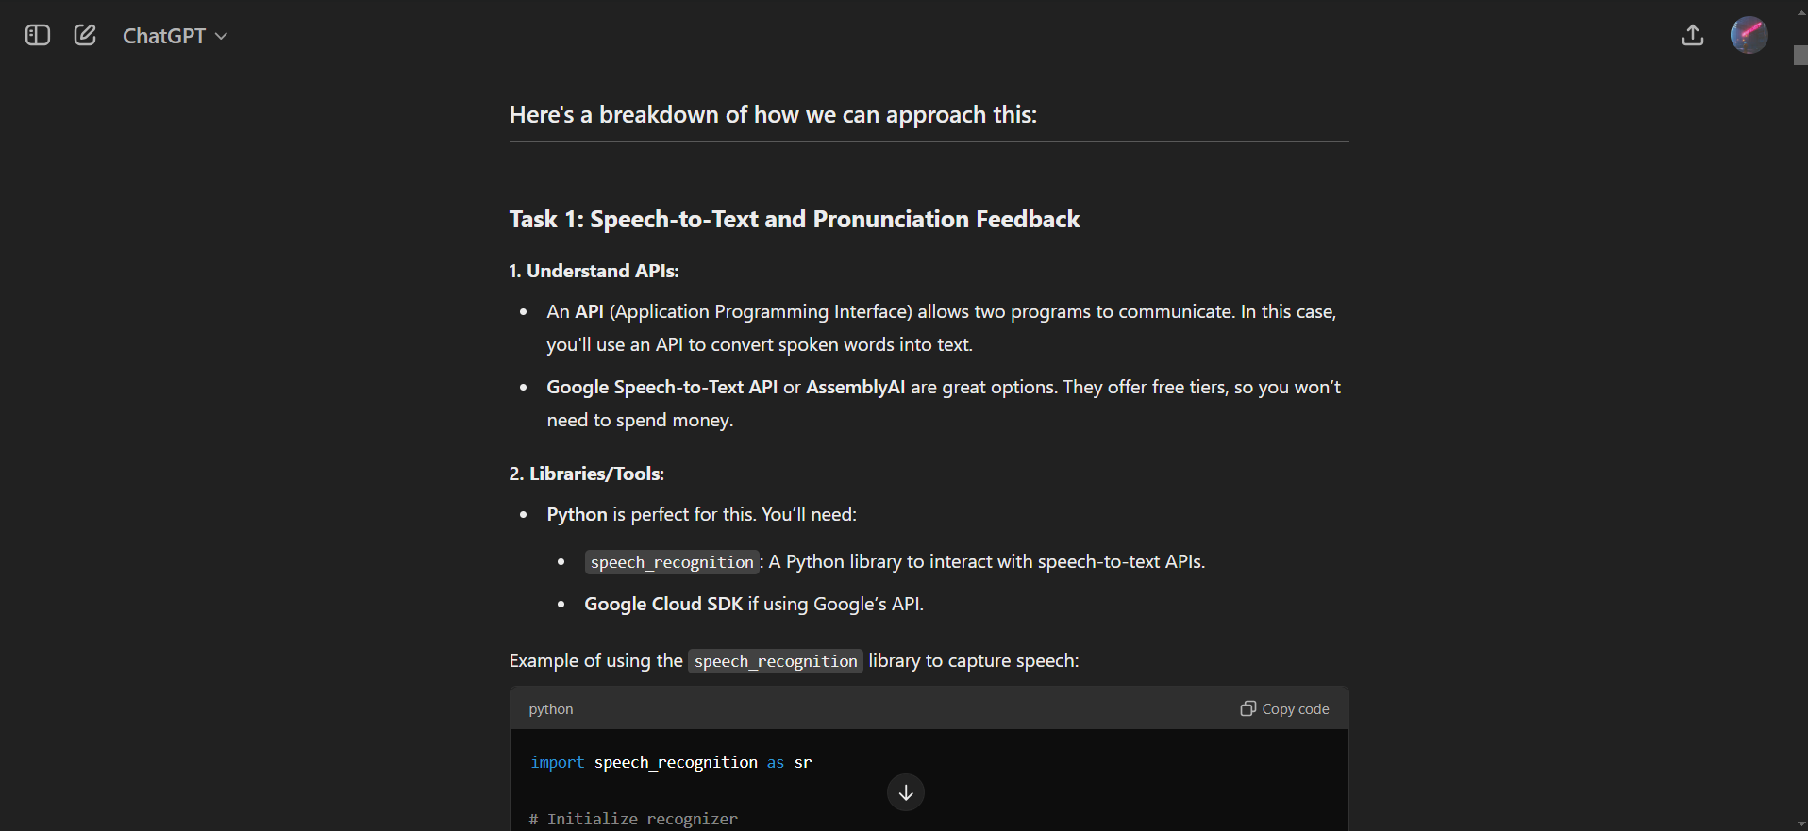

With this I had an idea of what the project was about and ChatGPT recommended that I use google cloud to get the speech to text API. Then I had to create an account on google cloud to access the API and to download the .json file which contains the API key, I learnt that this file is very important as it allows my program to communicate with the google API. I had run into some problems in the beginning because I didn’t understand it’s purpose and why my credentials where so important, so I had to create and set up the relevant credentials in order to allow the API to work with my program. And then I also had the chance of being acquainted with the python libraries speech_recognition, pronouncing, tkinter, difflib,

threading, os, and re. After I had tested the functionality of the tool I had to create a git repository, and I got to learn the different commands that could be used on the terminal in order to upload the files and again I learnt the importance of API keys especially the google credentials that are needed to access the APIs and how they could be misused if they are publicly available.  
A lot of the problems I had resolved by using ChatGPT because I find that it is the best tool to use for getting specific troubleshooting methods.